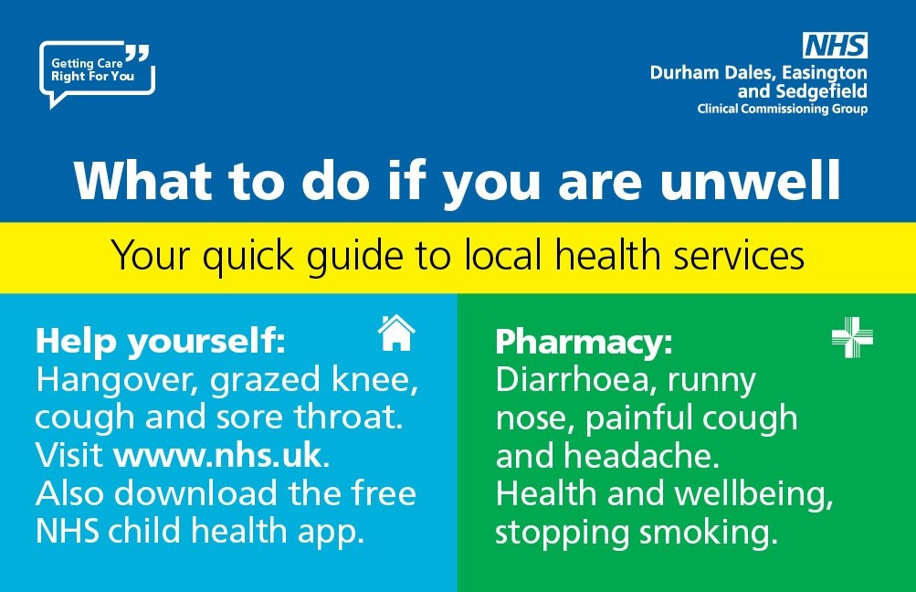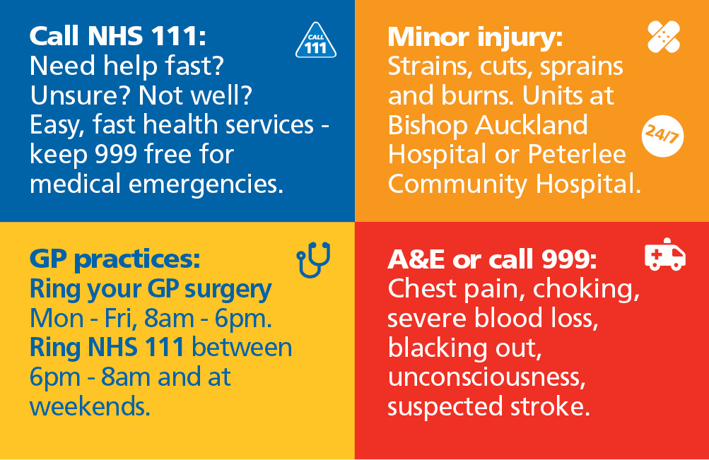
Enhanced Primary Care Access

What to do if you are unwell
Patients who need to be seen urgently on the same day will be offered a same day appointment either at the GP practice or at a nearby Primary Care Service 8am – 8pm Monday to Friday and 8am – 1pm Saturday to Sunday.
In the first instance, call the practice on 0191 526 5818 8am-6pm Monday to Friday.
Otherwise, please call NHS 111. They will sign post you to the appropriate service.

Help yourself
Check your first aid kit is well stocked. Be prepared with basic medical supplies, eg pain relief tablets, plasters and antiseptic wipes.
NHS choices can help you understand how to treat some health conditions such as a common cold. Visit NHS Choices at www.nhs.uk

Pharmacy
Pharmacies can help you with:
- Coughs and colds
- Aches
- Runny nose
- Pains
- Hay Fever
- Headaches
- Healthy eating advice
- Emergency contraception
- Stopping smoking
Search NHS Choices for your nearest pharmacy: www.nhs.uk

Minor Injury
24/7, 365 days a year you can go to a minor injuries unit at:
Peterlee Community Hospital, SR8 5UQ
We would advise that you call NHS 111 to get an appointment to reduce your waiting times.
Examples of minor injuries are:
- Sprains and strains
- Broken bones
- Wound infections
- Minor burns and scalds
- Minor head injuries
- Minor eye injuries
- Insect and animal bites

NHS 111
If you’re unsure of what health care to access call NHS 111. NHS 11 is available 24 hours a day, 365 days a year can advise on alternative local NHS services available.
Talk before you walk – it’s fast, easy and free!

Medical Emergency
Call 999 in a medical emergency, when someone is seriously ill or injured and their life is at risk. This could include:
- Heart attack
- Stroke
- Severe confused state
- Fits that are not stopping
- Severe allergic reactions, burns or scalds
- Severe bleeding that cannot be stopped
- Persistent, severe chest pain

